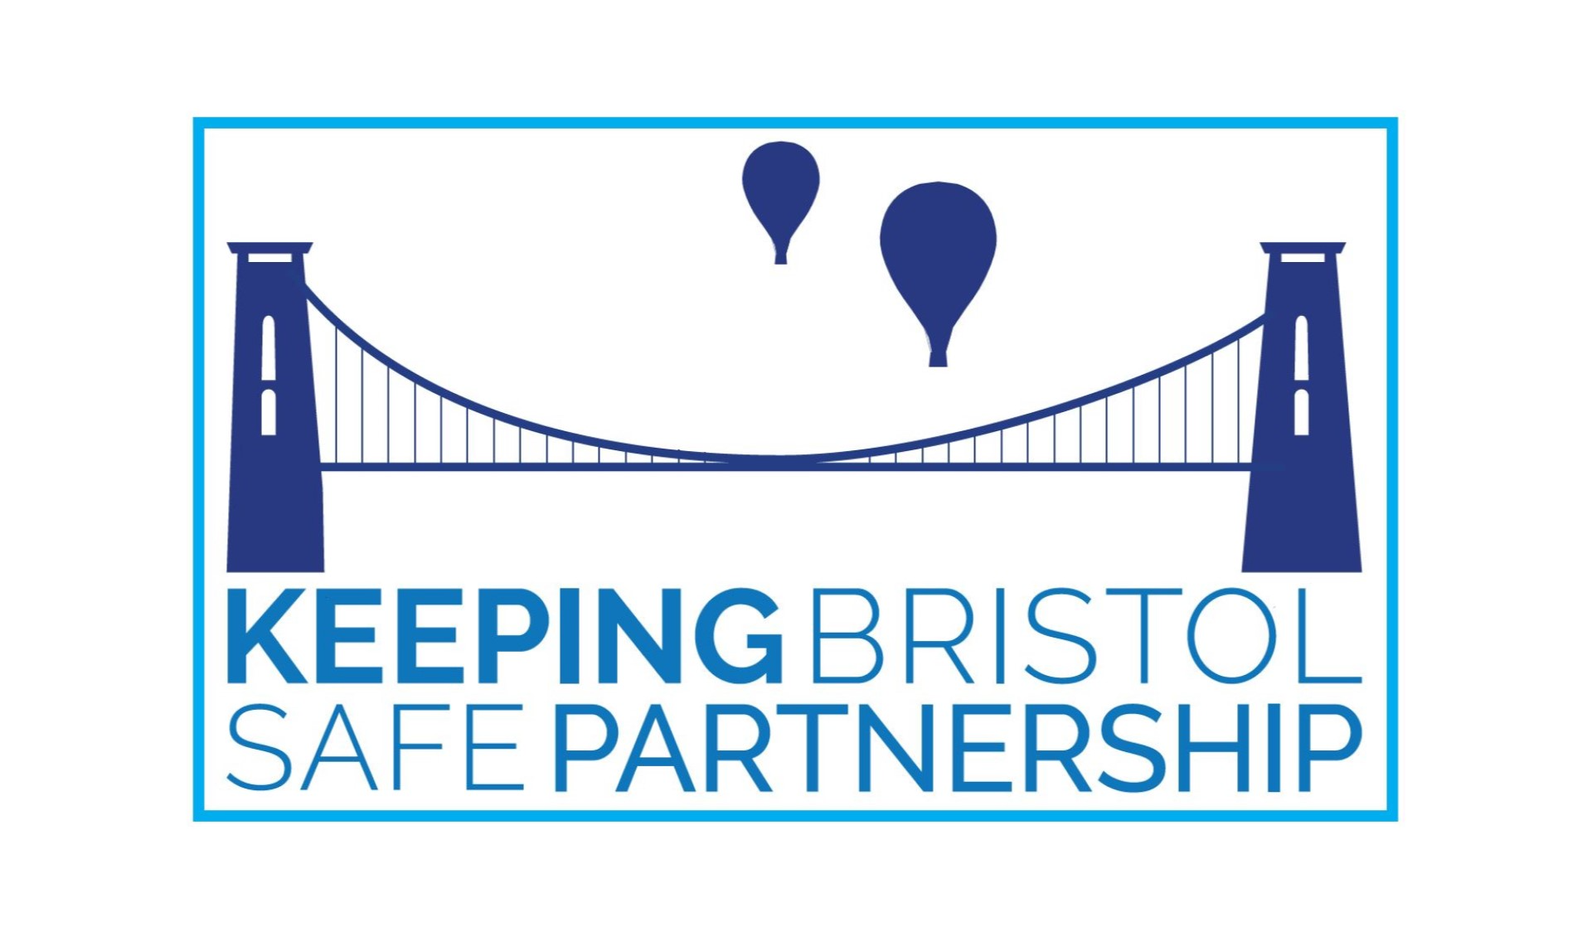
Keeping Adults Safe Board Independent Chair – Application Process Stage 1

With reference to the Service Specification, please respond to the below questions with a maximum of 500 words for each question.
Please email your responses, along with a copy of your CV to KBSP@bristol.gov.uk by midnight on Sunday 8th February 2026
Following assessment of applications, Stage 2 interviews will take place for successful candidate's w/c Monday 16th February 2026.
Question 1: Strategic Leadership & Independence (max 500 words)
Describe how you have demonstrated independent and strategic leadership within a complex safeguarding or public protection environment. How did you balance challenge with collaboration to drive improvement and ensure the voices of adults, families and communities were central to decision-making?

Question 2: Partnership, Influence & Co-production (max 500 words)
Provide an example of how you have influenced and strengthened multi-agency working across diverse partners. What approaches did you take to build shared ownership, especially where organisational priorities or cultures differed, and how did you embed co-production in that process?

Question 3: Assurance, Governance & Learning Culture (max 500 words)
Tell us about a time when you led or oversaw an assurance, review or learning process (for example, a Safeguarding Adults Review, audit or thematic learning exercise). How did you ensure findings led to measurable improvements and a culture of continuous learning across agencies?

Question 4: Vision, Values & Safeguarding Ethos (max 500 words)
Bristol is one city made up of many diverse communities. What does effective safeguarding leadership mean to you in that context? How would you ensure the Board continues to operate as an inclusive, learning, and outward-looking partnership that drives real impact for adults at risk?

